**antigen–antibody reactions**

The interactions between antigens and antibodies are known as **antigen–antibody reactions**. The reactions are highly specific, and an antigen reacts only with antibodies produced by itself or with closely related antigens. Antibodies recognize molecular shapes (epitopes) on antigens. Generally, the better the fit of the epitope (in terms of geometry and chemical character) to the antibody combining site, the more favorable the interactions that will be formed between the antibody and antigen and the higher the affinity of the antibody for antigen. The affinity of the antibody for the antigen is one of the most important factors in determining antibody efficacy in vivo.

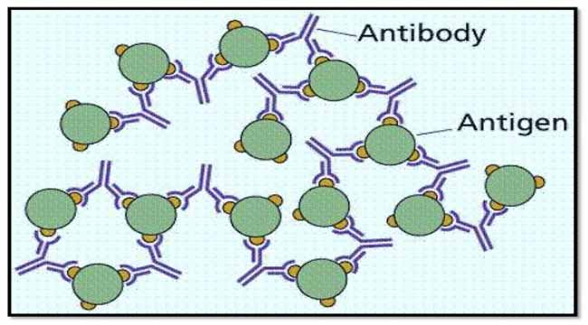

The antigen- antibody interaction is bimolecular irreversible association between antigen and antibody. The association between antigen and antibody includes various non-covalent interactions between epitope (antigenic determinant) and variable region (VH/VL) domain of antibody.

**Chemical Bonds Responsible for the Antigen–Antibody Reaction**

The interaction between the Ab-binding site and the epitope involves exclusively non-covalent bonds, in a similar manner to that in which proteins bind to their cellular receptors, or enzymes bind to their substrates. The binding is reversible and can be prevented or dissociated by high ionic strength or extreme pH. The following intermolecular forces are involved in Ag–Ab binding:

1. **Electrostatic bonds:** This result from the attraction between oppositely charged ionic groups of two protein side chains; for example, an ionized amino group (NH4+) on a lysine in the Ab, and an ionized carboxyl group (COO_) on an aspartate residue in the Ag.
2. **Hydrogen bonding**: When the Ag and Ab are in very close proximity, relatively weak hydrogen bonds can be formed between hydrophilic groups (e.g., OH and C=O, NH and C=O, and NH and OH groups).
3. **Hydrophobic interactions**: Hydrophobic groups, such as the side chains of valine, leucine, and phenylalanine, tend to associate due to Van der Waals bonding and coalesce in an aqueous environment, excluding water molecules from their surroundings. As a consequence, the distance between them decreases, enhancing the energies of attraction involved. This type of interaction is estimated to contribute up to 50% of the total strength of the Ag–Ab bond.
4. **Van der Waals bonds:** These forces depend upon interactions between the “electron clouds” that surround the Ag and Ab molecules. The interaction has been compared to that which might exist between alternating dipoles in two molecules, alternating in such a way that, at any given moment, oppositely oriented dipoles will be present in closely apposed areas of the Ag and Ab molecules.

Each of these non-covalent interactions operates over very short distance (generally about 1 Å) so, Ag-Ab interactions depends on very close fit between antigen and antibody.

## ****Strength of Ag-Ab interactions****

1. **Immune Complex**

When antigen and antibody are brought together the antibody binds with a antigen to form a complex molecule called immune complex or antigen- antibody complex (Ag – Ab complex). Ag+Ab------🡪 Ag-Ab Complex

1. **Specificity of Ag-Ab Reaction**

The reaction between antigen and antibody is highly specific. Specificity refers to the discriminate ability of a particular antibody to combine with only one type of antigen. The specificity of the Ag-Ab reaction can be compared to lock and key system.

1. **Binding sites of Antigen and Antibody.**

In antigen – antibody reaction, the antibody attaches with the antigen. The part of the antigen which combines with the antibody is called epitope or antigenic determinant. An antigen may contain 10 to 50 antigenic determinants.

The part of the antibody which combines with the antigen is called paratope or antigen binding site. Most of the antibodies are bivalent having two binding sites, but the antibody IgM is multivalent having 5 to 10 binding sites.

1. **Binding Forces of Antigen and Antibody**

The binding between antigen and antibody is due to three factors.

a) Closeness between antigen and antibody

b) Intermolecular forces

c) Affinity of antibody

1. **Affinity**

Combined strength of total non-covalent interactions between single Ag- binding site of Ab and single epitope is affinity of Ab for that epitope.

Low affinity Ab: Bind Ag weakly and dissociates readily.

High affinity Ab: Bind Ag tightly and remain bound longer

6**. Avidity**

Strength of multiple interactions between multivalent Ab and Ag is avidity. Avidity is better measure of binding capacity of antibody than affinity. High avidity can compensate low affinity.

7. **Cross reactivity**

Antibody elicited by one Ag can cross react with unrelated Ag if they share identical epitopeor have similar chemical properties.

## ****Types of Ag-Ab reactions****

1. Agglutination

Agglutination is an [antigen-antibody reaction](https://microbenotes.com/introduction-to-antigen-antibody-reactions/) in which a particulate antigen combines with its antibody in the presence of electrolytes at a specified temperature and pH resulting in the formation of visible clumping of particles. It occurs optimally when antigens and antibodies react in equivalent proportions. This reaction is analogous to the precipitation reaction in that antibodies act as a bridge to form a lattice network of antibodies and the cells that carry the antigen on their surface. Because cells are so much larger than a soluble antigen, the result is more visible when the cells aggregate into clumps.

Agglutination is the visible expression of the aggregation of antigens and antibodies. Agglutination reactions apply to particulate test antigens that have been conjugated to a carrier. The carrier could be artificial (such as latex or charcoal particles) or biological (such as red blood cells). These conjugated particles are reacted with patient serum presumably containing antibodies. The endpoint of the test is the observation of clumps resulting from that antigen-antibody complex formation. The quality of the result is determined by the time of incubation with the antibody source, amount and avidity of the antigen conjugated to the carrier, and conditions of the test environment (e.g., pH and protein concentration). Various methods of agglutination are used in diagnostic immunology and these include latex agglutination, flocculation tests, direct bacterial agglutination, and hemagglutination.

Agglutination differs from precipitation reaction in that since agglutination reaction takes place at the surface of the particle involved, the antigen must be exposed and be able to bind with the antibody to produce visible clumps. In agglutination reactions, serial dilutions of the antibody solution are made and a constant amount of particulate antigen is added to serially diluted antibody solutions. After several hours of incubation at 37°C, clumping is recorded by visual inspection. The titer of the antiserum is recorded as the reciprocal of the highest dilution that causes clumping. Since the cells have many antigenic determinants on their surface, the phenomenon of antibody excess is rarely encountered.

Agglutination is defined as the formation of clumps of cells or inert particles by specific antibodies to surface antigenic components (direct agglutination) or to antigenic components adsorbed or chemically coupled to red cells or inert particles (passive hemagglutination and passive [agglutination](https://www.sciencedirect.com/topics/immunology-and-microbiology/antigen-antibody-interaction),

# Types of Agglutination Reactions

Agglutination reactions can be broadly divided into three groups:

1. Active/Direct agglutination
2. Passive agglutination
3. Hemagglutination

**1. Active agglutination**

Agglutination reactions where the antigens are found naturally on a particle are known as direct agglutination. In active agglutination, direct agglutination of particulate antigen with specific antibody occurs. Direct bacterial agglutination uses whole pathogens as a source of antigen. It measures the antibody level produced by a host infected with that pathogen. The binding of antibodies to surface antigens on the bacteria results in visible clumps Active agglutination can be of following types:

1. **Slide/Tile agglutination:** Basic type of agglutination reaction that is performed on a slide. Identification of bacterial types represents a classic example of a slide agglutination. In this method suspension of unknown antigen is kept on slide and a drop of standardized antiserum is added or vice versa. A positive reaction is indicated by formation of visible clumps. E.g. Widal test, RPR test.
2. **Tube agglutination:**It is agglutination test performed in tube and standard quantitative technique for determination of antibody titre. In this method serum is diluted in a series of tubes and standard antigen suspensions (specific for the suspected disease) are added to it. After incubation, antigen-antibody reaction is indicated visible clumps of agglutination.
3. **Heterophile agglutination test:**This test depends on demonstration of heterophilic antibodies in serum present in certain bacterial infections.
4. **Antiglobulin (Coombs) test:**This’ test was devised by Coombs, Mourant, and Race for detection of incomplete anti-Rh antibodies that do not agglutinate Rh+ erythrocytes in saline. When serum containing incomplete anti-Rh antibodies is mixed with Rh+ erythrocytes in saline, incomplete antibody antiglobulin coats the surface of erythrocytes but does not cause any agglutination. When such erythrocytes are treated with antiglobulin or Coombs serum (rabbit antiserum against human gamma globulin), then the cells are agglutinated. Coombs test can be direct as well as indirect**.**

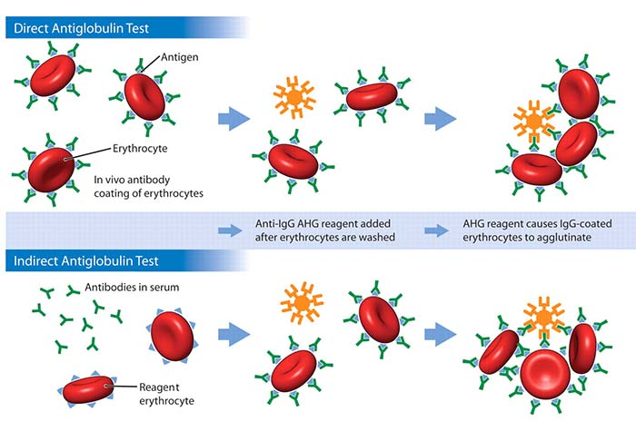

In **direct method**, the sensitization of red blood cells (RBCs) with incomplete antibodies takes place in vivo. Cell-bound antibodies can be detected by this test in which antiserum against human immunoglobulin is used to agglutinate patient’s RBC. In **indirect method**, the sensitization of RBCs with incomplete antibodies takes place in vitro. Patient’s serum is mixed with normal red cells and antiserum to human immunoglobulin. Agglutination occurs if antibodies are present in serum. **Coombs test is used for detection of anti-Rh antibodies and incomplete antibodies in brucellosis and other diseases**.

**2. Passive Agglutination**

Passive agglutination employs carrier particles that are coated with soluble antigens. In this either antibody or antigen is attached to certain inert carrier thereby, particles or cells gets agglutinated when corresponding antigen or antibody reacts. Latex particles, Carbon particles, Bantonite etc. are used as inert carriers. E.g. Antigens coated in latex particles used in ASO test. When the antibody instead of antigens is adsorbed on the carrier particle for detection of antigens, it is called **reverse** **passive agglutination.**

**Latex Agglutination:**It employs latex particles as carrier of antigen or antibodies. In latex agglutination, many antibody or antigen molecules are bound to latex beads (particles), which increases the number of antigen-binding sites. If corresponding antigen or antibody is present in a test specimen, antigen antibody bind and form visible, cross-linked aggregates. Latex agglutination can also be performed with the antigen conjugated to the beads for testing the presence of antibodies in a serum specimen.

**3. Hemagglutination test**

RBCs are used as carrier particles in hemagglutination tests. RBCs of sheep, human, chick, etc. are commonly used in the test. When RBCs are coated with antigen to detect antibodies in the serum, the test is called **indirect hemagglutination (IHA) test**. Hemagglutination uses erythrocytes as the biological carriers of bacterial antigens, and purified polysaccharides or proteins for determining the presence of corresponding antibodies in a specimen. When antibodies are attached to the RBCs to detect microbial antigen, it is known as **reverse passive hemagglutination** **(RPHA)**.

**Viral hemagglutination:**Many viruses including influenza, mumps, and measles have the ability to agglutinate RBCs without antigen–antibody reactions. This process is called viral hemagglutination. This hemagglutination can be inhibited by antibody specifically directed against the virus, and this phenomenon is called **hemagglutination inhibition**.

**Coagglutination test:**Coagglutination is a type of agglutination reaction in which Cowan I strain of S. aureus is used as carrier particle to coat antibodies. Cowan I strain of S. aureus contains protein A, an anti-antibody, that combines with the Fc portion of immunoglobulin, IgG, leaving the Fab region free to react with the antigen present in the specimens. In a positive test, protein A bearing S. aureus coated with antibodies will be agglutinated if mixed with specific antigen. The advantage of the test is that these particles show greater stability than latex particles and are more refractory to changes in ionic strength.

**Uses of Coagglutination test**

1. Detection of cryptococcal antigen in the CSF for diagnosis of cryptococcal meningitis;
2. Detection of amoebic and hydatid antigens in the serum for diagnosis of amoebiasis and cystic echinococcosis,
3. Grouping of streptococci and mycobacteria and for typing of *Neisseria gonorrhoeae.*