CORE THEORY PAPER – 7
DATA COMMUNICATION & NETWORKS

UNIT III

Network Layer : Design issues, Routing Algorithms, Shortest path routing, Flooding,
Broadcast & Multicast routing congestion, Control & internetworking.

UNIT III – NETWORK LAYER

3.1 Introduction:

The network layer is the third level of the Open Systems Interconnection Model (OSI Model) and the layer that provides data routing paths for network communication. Data is transferred in the form of packets via logical network paths in an ordered format controlled by the network layer.

Logical connection setup, data forwarding, routing and delivery error reporting are the network layer’s primary responsibilities.

3.2 Network Layer Design Issues:

In the following sections we will provide an introduction to some of the issues that the designers of the network layer must grapple with. These issues include the service provided to the transport layer and the internal design of the subnet.

3.2.1 Store-and-Forward Packet Switching

- The network layer protocols operation can be seen in Figure.

- The major components of the system are the carrier's equipment (routers connected by transmission lines), shown inside the shaded oval.
- The customers' equipment, shown outside the oval. Host H1 is directly connected to one of the carrier's routers, A, by a leased line. In contrast, H2 is on a LAN with a router, F, owned and operated by the customer. This router also has a leased line to the carrier's equipment.

- We have shown F as being outside the oval because it does not belong to the carrier, but in terms of construction, software, and protocols, it is probably no different from the carrier's routers. Whether it belongs to the subnet is arguable, but for the purposes of this chapter, routers on customer premises are considered part of the subnet.

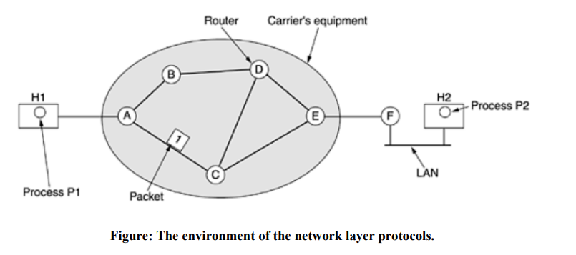

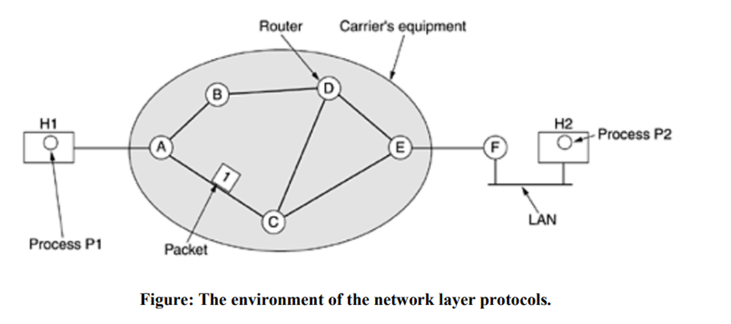

- A host with a packet to send transmits it to the nearest router, either on its own LAN or over a point-to-point link to the carrier.

- The packet is stored there until it has fully arrived so the checksum can be verified. Then it is forwarded to the next router along the path until it reaches the destination host, where it is delivered.
- This mechanism is store-and-forward packet switching.

3.2.2 Services Provided to the Transport Layer

The network layer provides services to the transport layer at the network layer/transport layer interface. The network layer services have been designed with the following goals in mind.

  - The services should be independent of the router technology.

  - The transport layer should be shielded from the number, type, and topology of the

routers present.

  - The network addresses made available to the transport layer should use a uniform numbering plan, even across LANs and WANs.

- There is a discussion centers on whether the network layer should provide connection oriented service or connectionless service.

- In their view (based on 30 years of actual experience with a real, working computer network), the subnet is inherently unreliable, no matter how it is designed. Therefore, the hosts should accept the fact that the network is unreliable and do error control (i.e., error detection and correction) and flow control themselves.

- This viewpoint leads quickly to the conclusion that the network service should be connectionless, with primitives SEND PACKET and RECEIVE PACKET and little else.
- In particular, no packet ordering and flow control should be done, because the hosts are going to do that anyway, and there is usually little to be gained by doing it twice.

- Furthermore, each packet must carry the full destination address, because each packet sent is carried independently of its predecessors, if any.
- The other camp (represented by the telephone companies) argues that the subnet should provide a reliable, connection-oriented service.

- These two camps are best exemplified by the Internet and ATM. The Internet offers connectionless network-layer service; ATM networks offer connection-oriented network layer service. However, it is interesting to note that as quality-of-service guarantees are becoming more and more important, the Internet is evolving. In particular, it is starting to acquire properties normally associated with connection-oriented service.

3.2.3 Implementation of Connectionless Service

- Two different organizations are possible, depending on the type of service offered.

- If connectionless service is offered, packets are injected into the subnet individually and routed independently of each other. No advance setup is needed. In this context, the packets are frequently called datagrams (in analogy with telegrams) and the subnet is called a datagram subnet.

- If connection-oriented service is used, a path from the source router to the destination router must be established before any data packets can be sent. This connection is called a VC (virtual circuit), in analogy with the physical circuits set up by the telephone system, and the subnet is called a virtual-circuit subnet.

- Let us now see how a datagram subnet works. Suppose that the process P1 in Figure has a long message for P2. It hands the message to the transport layer with instructions to deliver it to process P2 on host H2. The transport layer code runs on H1, typically within the operating system. It prepends a transport header to the front of the message and hands the result to the network layer, probably just another procedure within the operating system.

operating system. It prepends a transport header to the front of the message and hands the result to the network layer, probably just another procedure within the operating system.

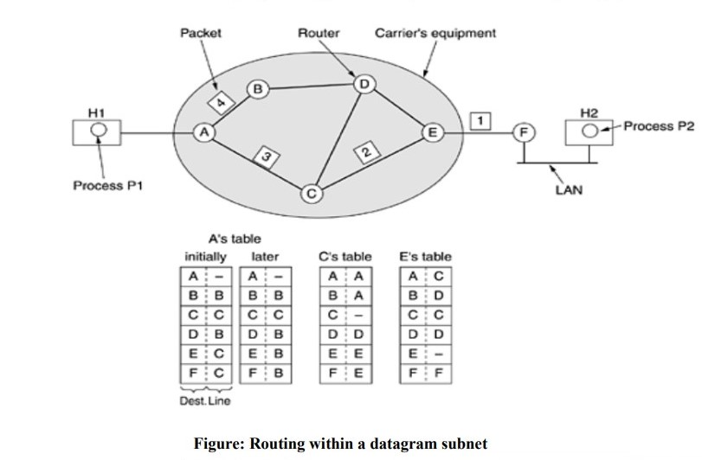

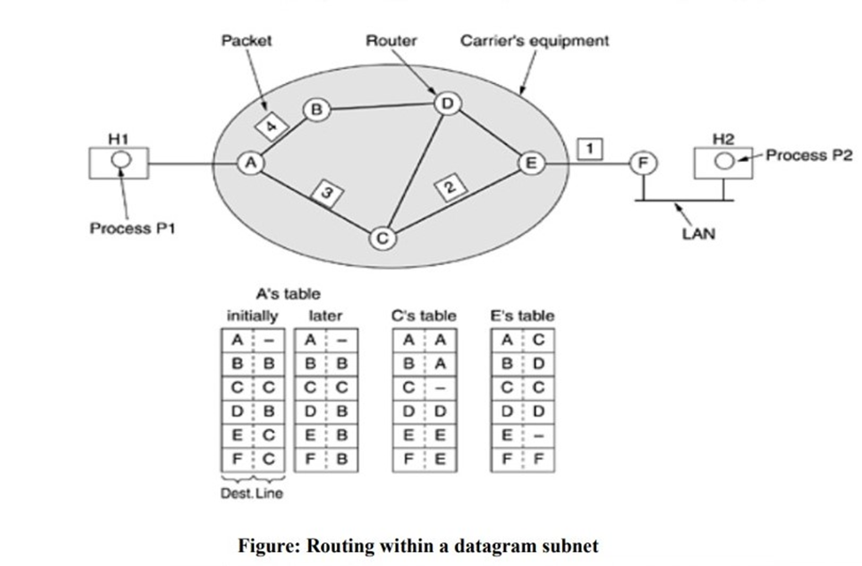

- Let us assume that the message is four times longer than the maximum packet size, so the network layer has to break it into four packets, 1, 2, 3, and 4 and sends each of them in turn to router A using some point-to-point protocol,
- For example, PPP. At this point the carrier takes over. Every router has an internal table telling it where to send packets for each possible destination. Each table entry is a pair consisting of a destination and the outgoing line to use for that destination. Only directly connected lines can be used.

- For example, in Figure, A has only two outgoing lines to B and C so every incoming packet must be sent to one of these routers, even if the ultimate destination is some other router. A's initial routing table is shown in the figure under the label ''initially''. As they arrived at A, packets 1, 2, and 3 were stored briefly (to verify their checksums). Then each was forwarded to C according to A's table. Packet 1 was then forwarded to E and then to F. When it got to F, it was encapsulated in a data link layer frame and sent to H2 over the LAN. Packets 2 and 3 follow the same route.

- However, something different happened to packet 4. When it got to A it was sent to router B, even though it is also destined for F. For some reason, A decided to send packet 4 via a different route than that of the first three. Perhaps it learned of a traffic jam somewhere along the ACE path and updated its routing table, as shown under the label ''later.''

- The algorithm that manages the tables and makes the routing decisions is called the routing algorithm.

3.2.4 Implementation of Connection-Oriented Service

- For connection-oriented service, we need a virtual-circuit subnet.

- The idea behind virtual circuits is to avoid having to choose a new route for every packet sent, as in Figure Instead, when a connection is established, a route from the source machine to the destination machine is chosen as part of the connection setup and stored in tables inside the routers.

- That route is used for all traffic flowing over the connection, exactly the same way that the telephone system works.
- When the connection is released, the virtual circuit is also terminated. With connection oriented service, each packet carries an identifier telling which virtual circuit it belongs to.

- As an example, consider the situation of Figure. Here, host H1 has established connection 1 with host H2. It is remembered as the first entry in each of the routing tables. The first line of A's table says that if a packet bearing connection identifier 1 comes in from H1, it is to be sent to router C and given connection identifier 1. Similarly, the first entry at C routes the packet to E, also with connection identifier 1.

Now let us consider what happens if H3 also wants to establish a connection to H2. It chooses connection identifier 1 (because it is initiating the connection and this is its only connection) and tells the subnet to establish the virtual circuit. This leads to the second row in the tables. Note that we have a conflict here because although A can easily distinguish connection 1 packets from H1 from connection 1 packets from H3, C cannot do this. For this reason, A assigns a different connection identifier to the outgoing traffic for the second

connection. Avoiding conflicts of this kind is why routers need the ability to replace connection identifiers in outgoing packets. In some contexts, this is called label switching.

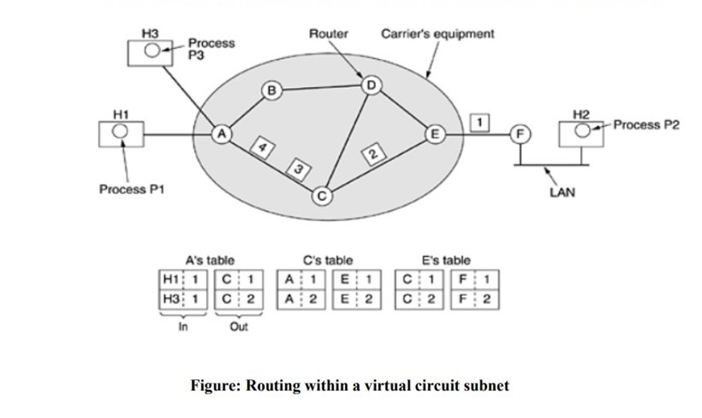

3.2.5 Comparison of Virtual-Circuit and Datagram Networks

The major issues are listed below

Issue |  | Datagram Subnet |  | Virtual-Circuit Subnet
Circuit Setup |  | Not needed |  | Required
Addressing |  | Each packet contains the full source |  | Each packet contains a short VC
Addressing |  | and destination address |  | number
State information |  | Routers do not hold state information |  | Each VC requires router table space
State information |  | about connections |  | per connection
 |  |  |  | Route chosen when VC is set up; all
Routing |  | Each packet is routed independently |  | packets follow it

Effect of router |  | None, except for packets lost during |  | All VCs that passed through the failed
failures |  | the crash |  | router are terminated
Quality of |  | Difficult |  | Easy if enough resources can be
Service |  | Difficult |  | allocated in advance for each VC
Quality of |  | Difficult |  | Easy if enough resources can be
Control |  | Difficult |  | allocated in advance for each VC

3.3 Routing Algorithms

Routing is the process of forwarding of a packet in a network so that it reaches its intended destination. The main goals of routing are:

- Correctness: The routing should be done properly and correctly so that the packets may reach their proper destination.

- Simplicity: The routing should be done in a simple manner so that the overhead is as low as possible. With increasing complexity of the routing algorithms the overhead also increases.

- Robustness: Once a major network becomes operative, it may be expected to run continuously for years without any failures. The algorithms designed for routing should be robust enough to handle hardware and software failures and should be able to cope with changes in the topology and traffic without requiring all jobs in all hosts to be aborted and the network rebooted every time some router goes down.

- Stability: The routing algorithms should be stable under all possible circumstances.

- Fairness: Every node connected to the network should get a fair chance of transmitting their packets. This is generally done on a first come first serve basis.

- Optimality: The routing algorithms should be optimal in terms of throughput and minimizing mean packet delays. Here there is a trade-off and one has to choose depending on his suitability.

3.3.1 Shortest Path Algorithm

- A technique to study routing algorithms: The idea is to build a graph of the subnet, with each node of the graph representing a router and each arc of the graph representing a communication line (often called a link).
- To choose a route between a given pair of routers, the algorithm just finds the shortest path between them on the graph.

- One way of measuring path length is the number of hops. Another metric is the geographic distance in kilometers. Many other metrics are also possible. For example, each arc could be labeled with the mean queuing and transmission delay for some standard test packet as determined by hourly test runs.

- In the general case, the labels on the arcs could be computed as a function of the distance, bandwidth, average traffic, communication cost, mean queue length, measured delay, and other factors. By changing the weighting function, the algorithm would then compute the ''shortest'' path measured according to any one of a number of criteria or to a combination of criteria.

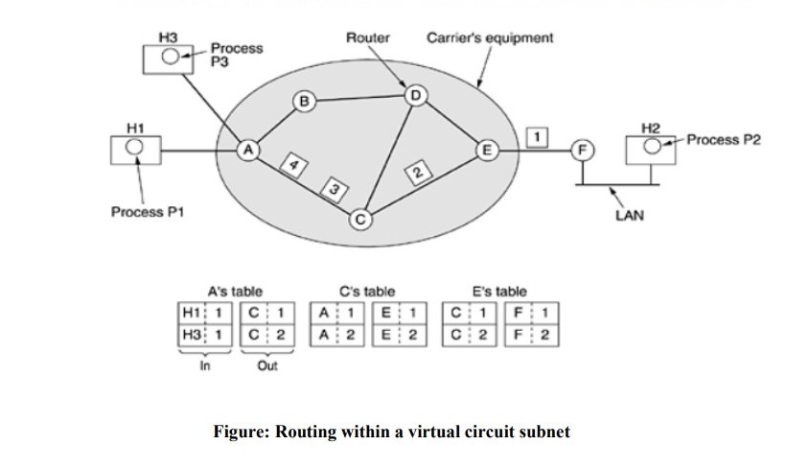

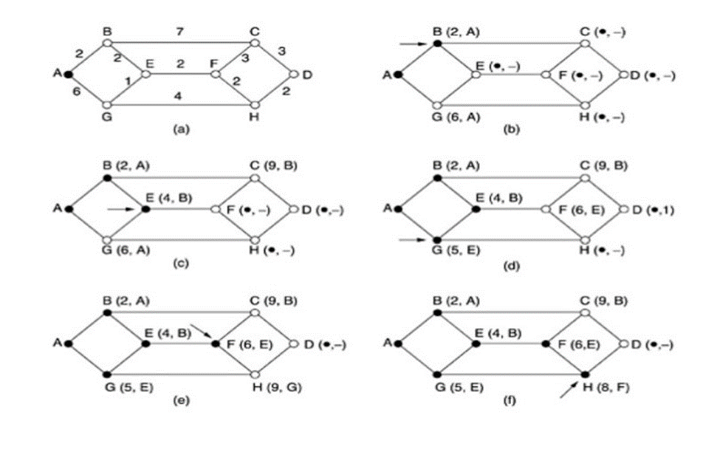

- To illustrate how the labeling algorithm works, look at the weighted, undirected graph of Fig. (a), where the weights represent, for example, distance.

- We want to find the shortest path from A to D. We start out by marking node A as permanent, indicated by a filled-in circle.
- Then we examine, in turn, each of the nodes adjacent to A (the working node), relabeling each one with the distance to A.

- Whenever a node is relabeled, we also label it with the node from which the probe was made so that we can reconstruct the final path later.

- Having examined each of the nodes adjacent to A, we examine all the tentatively labeled nodes in the whole graph and make the one with the smallest label permanent, as shown in Fig. (b).

- This one becomes the new working node. We now start at B and examine all nodes adjacent to it. If the sum of the label on B and the distance from B to the node being considered is less than the label on that node, we have a shorter path, so the node is relabeled.

- After all the nodes adjacent to the working node have been inspected and the tentative labels changed if possible, the entire graph is searched for the tentatively-labeled node with the smallest value. This node is made permanent and becomes the working node for the next round.

  - To see why the algorithm works, look at Fig. (c). At that point we have just made E permanent. Suppose that there were a shorter path than ABE, say AXYZE. There are two possibilities: either node Z has already been made permanent, or it has not been. If it has, then E has already been probed (on the round following the one when Z was made permanent), so the AXYZE path has not escaped our attention and thus cannot be a shorter path.

  - Now consider the case where Z is still tentatively labeled. Either the label at Z is greater than or equal to that at E, in which case AXYZE cannot be a shorter path than ABE, or it is less than that of E, in which case Z and not E will become permanent first, allowing E to be probed from Z.

3.3.2 Flooding

- Another static algorithm is flooding, in which every incoming packet is sent out on every outgoing line except the one it arrived on.
- Flooding obviously generates vast numbers of duplicate packets, in fact, an infinite number unless some measures are taken to damp the process.
- One such measure is to have a hop counter contained in the header of each packet, which is decremented at each hop, with the packet being discarded when the counter reaches zero.
- Ideally, the hop counter should be initialized to the length of the path from source to destination. If the sender does not know how long the path is, it can initialize the counter to the worst case, namely, the full diameter of the subnet.

3.3.3 Broadcast Routing

Sending a packet to all destinations simultaneously is called broadcasting.

- The source simply sends a distinct packet to each destination. Not only is the method wasteful of bandwidth, but it also requires the source to have a complete list of all destinations.

- Flooding.

The problem with flooding as a broadcast technique is that it generates too many packets and consumes too much bandwidth.

Reverse path forwarding. (a) A subnet (b) A sink tree (c) The tree built by reverse path forwarding

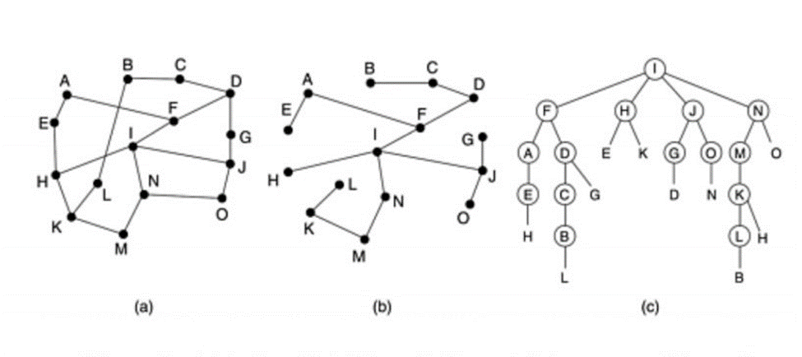

Part (a) shows a subnet, part (b) shows a sink tree for router I of that subnet, and part (c) shows how the reverse path algorithm works.

- When a broadcast packet arrives at a router, the router checks to see if the packet arrived on the line that is normally used for sending packets to the source of the broadcast. If so, there is an excellent chance that the broadcast packet itself followed the best route from the router and is therefore the first copy to arrive at the router.

- This being the case, the router forwards copies of it onto all lines except the one it arrived on. If, however, the broadcast packet arrived on a line other than the preferred one for reaching the source, the packet is discarded as a likely duplicate.

3.3.4 Multicast Routing

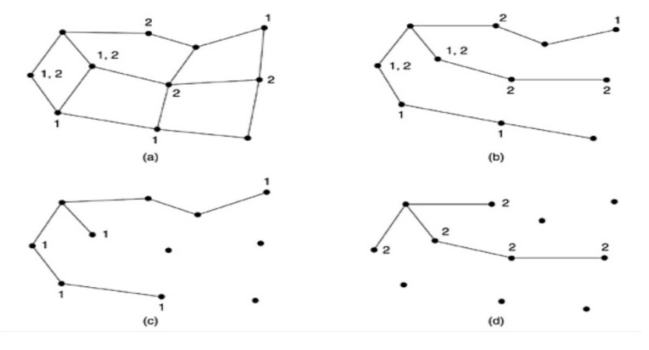

- To do multicast routing, each router computes a spanning tree covering all other routers. For example, in Fig. (a) we have two groups, 1 and 2.

- Some routers are attached to hosts that belong to one or both of these groups, as indicated in the figure.

- A spanning tree for the leftmost router is shown in Fig. (b). When a process sends a multicast packet to a group, the first router examines its spanning tree and prunes it, removing all lines that do not lead to hosts that are members of the group.
- In our example, Fig. (c) shows the pruned spanning tree for group 1. Similarly, Fig. (d) shows the pruned spanning tree for group 2. Multicast packets are forwarded only along the appropriate spanning tree.

3.4 Congestion Control Algorithms

- When too many packets are present in (a part of) the subnet, performance degrades. This situation is called congestion.

- The following Figure depicts the symptom. When the number of packets dumped into the subnet by the hosts is within its carrying capacity, they are all delivered (except for a few that are afflicted with transmission errors) and the number delivered is proportional to the number sent.

- However, as traffic increases too far, the routers are no longer able to cope and they begin losing packets. This tends to make matters worse. At very high traffic, performance collapses completely and almost no packets are delivered.

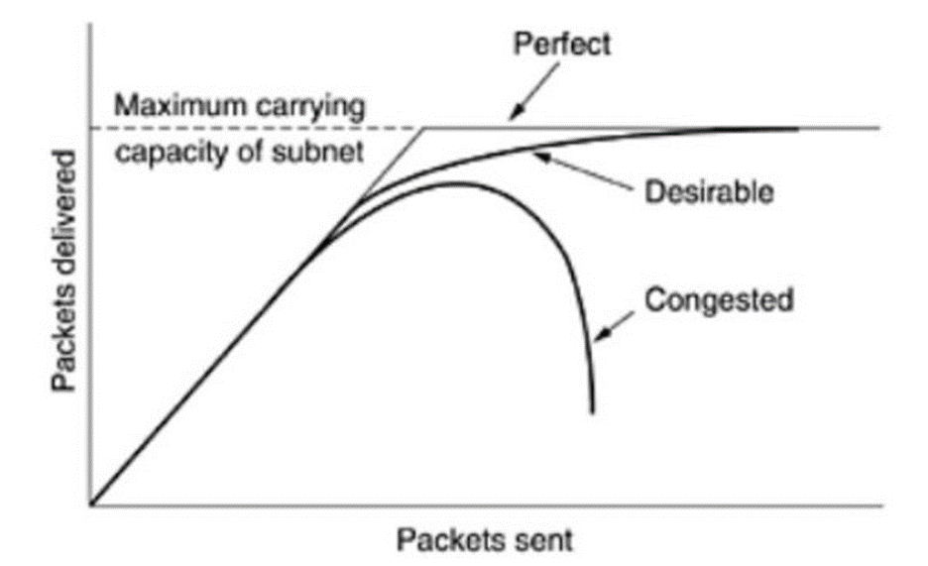

Figure: When too much traffic is offered, congestion sets in and performance degrades sharply

- Congestion can be brought on by several factors. If all of a sudden, streams of packets begin arriving on three or four input lines and all need the same output line, a queue will build up.
- If there is insufficient memory to hold all of them, packets will be lost.

- Slow processors can also cause congestion. If the routers' CPUs are slow at performing the bookkeeping tasks required of them (queuing buffers, updating tables, etc.), queues can build up, even though there is excess line capacity. Similarly, low-bandwidth lines can also cause congestion.

3.4.1 Approaches to Congestion Control

- Many problems in complex systems, such as computer networks, can be viewed from a control theory point of view. This approach leads to dividing all solutions into two groups: open loop and closed loop.

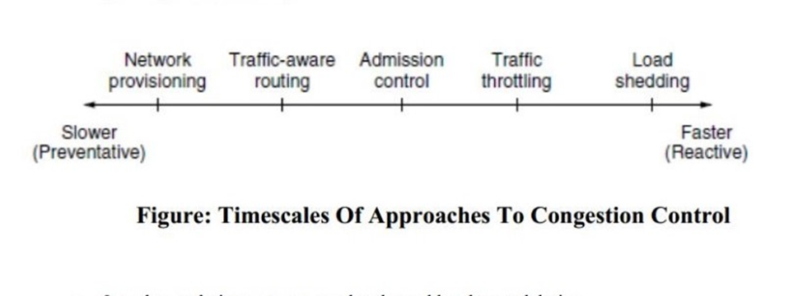
- Open loop solutions attempt to solve the problem by good design.

- Tools for doing open-loop control include deciding when to accept new traffic, deciding when to discard packets and which ones, and making scheduling decisions at various points in the network.
- Closed loop solutions are based on the concept of a feedback loop.

- This approach has three parts when applied to congestion control:

  - Monitor the system to detect when and where congestion occurs.

  - Pass this information to places where action can be taken.

  - Adjust system operation to correct the problem.

- A variety of metrics can be used to monitor the subnet for congestion. Chief among these are the percentage of all packets discarded for lack of buffer space, the average queue lengths, the number of packets that time out and are retransmitted, the average packet delay, and the standard deviation of packet delay. In all cases, rising numbers indicate growing congestion.

- The second step in the feedback loop is to transfer the information about the congestion from the point where it is detected to the point where something can be done about it.
- In all feedback schemes, the hope is that knowledge of congestion will cause the hosts to take appropriate action to reduce the congestion.

- The presence of congestion means that the load is (temporarily) greater than the resources (in part of the system) can handle. Two solutions come to mind: increase the resources or decrease the load.

3.4.2 Traffic-Aware Routing

- These schemes adapted to changes in topology, but not to changes in load. The goal in taking load into account when computing routes is to shift traffic away from hotspots that will be the first places in the network to experience congestion.
- The most direct way to do this is to set the link weight to be a function of the (fixed) link bandwidth and propagation delay plus the (variable) measured load or average queuing delay. Least-weight paths will then favor paths that are more lightly loaded, all else being equal.

- Consider the network of Fig, which is divided into two parts, East and West, connected by two links, CF and EI. Suppose that most of the traffic between East and West is using link CF, and, as a result, this link is heavily loaded with long delays. Including queueing delay in the weight used for the shortest path calculation will make EI more attractive. After the new routing tables have been installed, most of the East-West traffic will now go over EI, loading this link. Consequently, in the next update, CF will appear to be the shortest path. As a result, the routing tables may oscillate wildly, leading to erratic routing and many potential problems.

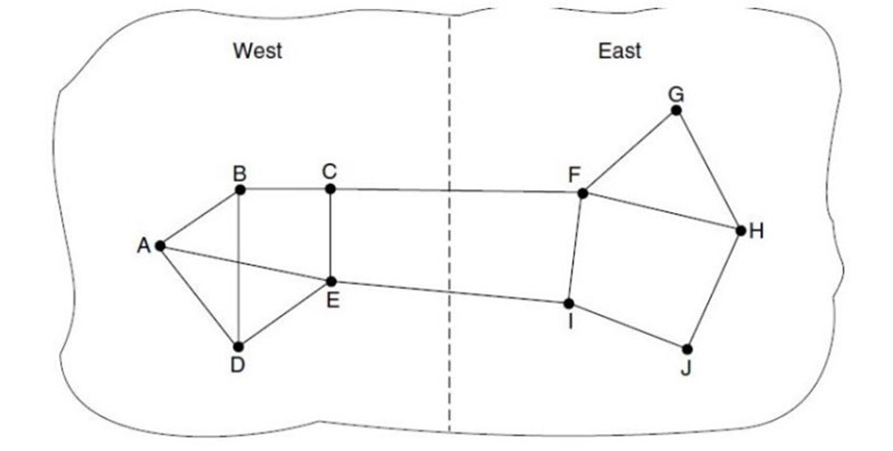

- If load is ignored and only bandwidth and propagation delay are considered, this problem does not occur. Attempts to include load but change weights within a narrow range only slow down routing oscillations. Two techniques can contribute to a successful solution. The first is multipath routing, in which there can be multiple paths from a source to a destination. In our example this means that the traffic can be spread across both of the East to West links. The second one is for the routing scheme to shift traffic across routes slowly enough that it is able to converge.

3.4.3 Admission Control

- One technique that is widely used to keep congestion that has already started from getting worse is admission control.
- Once congestion has been signaled, no more virtual circuits are set up until the problem has gone away.

- An alternative approach is to allow new virtual circuits but carefully route all new virtual circuits around problem areas. For example, consider the subnet of Fig. (a), in which two routers are congested, as indicated.

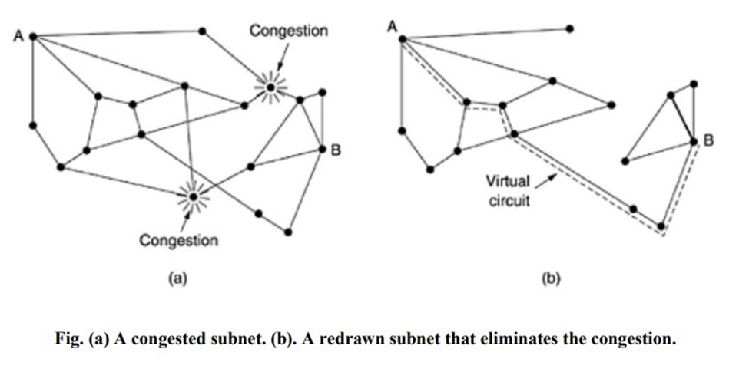

Suppose that a host attached to router A wants to set up a connection to a host attached to router B. Normally, this connection would pass through one of the congested routers. To avoid this situation, we can redraw the subnet as shown in Fig. (b), omitting the congested routers and all of their lines. The dashed line shows a possible route for the virtual circuit that avoids the congested routers.

3.4.4 Traffic Throttling

- Each router can easily monitor the utilization of its output lines and other resources. For example, it can associate with each line a real variable, u, whose value, between 0.0 and 1.0, reflects the recent utilization of that line. To maintain a good estimate of u, a sample of the instantaneous line utilization, f (either 0 or 1), can be made periodically and u updated according to
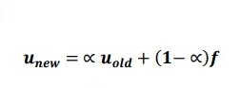
where the constant a determines how fast the router forgets recent history.

Whenever u moves above the threshold, the output line enters a ''warning'' state. Each newly arriving packet is checked to see if its output line is in warning state. If it is, some action is taken. The action taken can be one of several alternatives, which we will now discuss.

3.4.4.1 Choke Packets

- In this approach, the router sends a choke packet back to the source host, giving it the destination found in the packet.
- The original packet is tagged (a header bit is turned on) so that it will not generate any more choke packets farther along the path and is then forwarded in the usual way.
- When the source host gets the choke packet, it is required to reduce the traffic sent to the specified destination by X percent. Since other packets aimed at the same destination are probably already under way and will generate yet more choke packets, the host should ignore choke packets referring to that destination for a fixed time interval. After that period has expired, the host listens for more choke packets for another interval. If one arrives, the line is still congested, so the host reduces the flow still more and begins ignoring choke packets again. If no choke packets arrive during the listening period, the host may increase the flow again.
- The feedback implicit in this protocol can help prevent congestion yet not throttle any flow unless trouble occurs.
- Hosts can reduce traffic by adjusting their policy parameters.

- Increases are done in smaller increments to prevent congestion from reoccurring quickly.

- Routers can maintain several thresholds. Depending on which threshold has been crossed, the choke packet can contain a mild warning, a stern warning, or an ultimatum.

3.4.4.2 Hop-By-Hop Back Pressure

- At high speeds or over long distances, sending a choke packet to the source hosts does not work well because the reaction is so slow.

- Consider, for example, a host in San Francisco (router A in Fig.) that is sending traffic to a host in New York (router D in Fig.) at 155 Mbps. If the New York host begins to run out of buffers, it will take about 30 msec for a choke packet to get back to San Francisco to tell it to slow down. The choke packet propagation is shown as the second, third, and fourth steps in Fig. (a). In those 30 msec, another 4.6 megabits will have been sent. Even if the host in San Francisco completely shuts down immediately, the 4.6 megabits in the pipe will continue to pour in and have to be dealt with. Only in the seventh diagram in Fig. (a) will the New York router notice a slower flow.

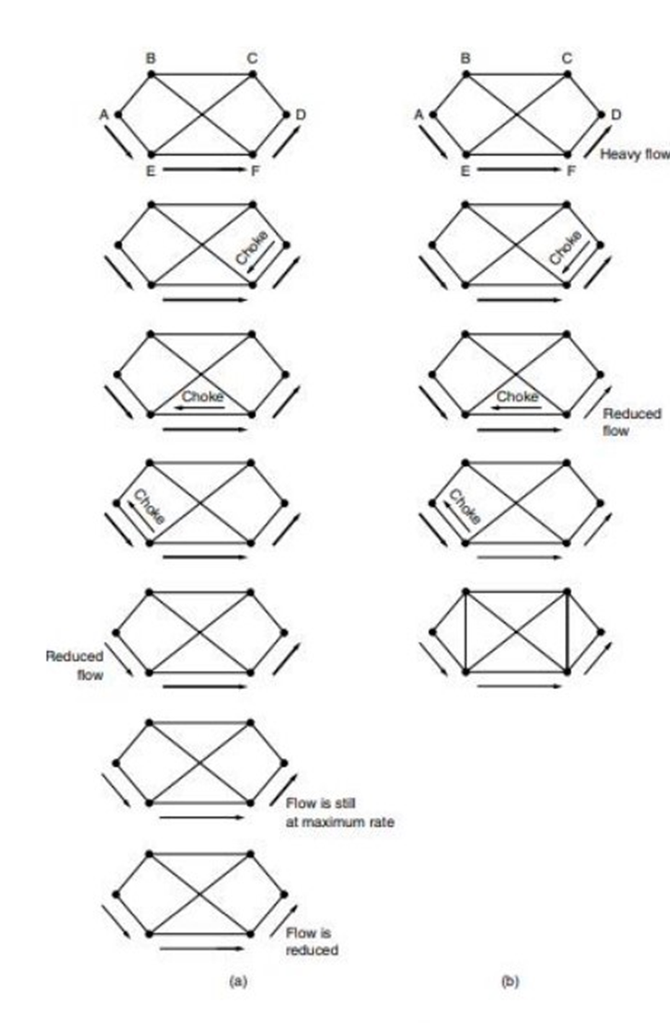

- An alternative approach is to have the choke packet take effect at every hop it passes through, as shown in the sequence of Fig. (b). Here, as soon as the choke packet reaches F, F is required to reduce the flow to D. Doing so will require F to devote more buffers to the flow, since the source is still sending away at full blast, but it gives D immediate relief, like a headache remedy in a television commercial. In the next step, the choke packet reaches E, which tells E to reduce the flow to F. This action puts a greater demand on E's buffers but gives F immediate relief. Finally, the choke packet reaches A and the flow genuinely slows down.

- The net effect of this hop-by-hop scheme is to provide quick relief at the point of congestion at the price of using up more buffers upstream. In this way, congestion can be nipped in the bud without losing any packets.

3.4.5 Load Shedding

- When none of the above methods make the congestion disappear, routers can bring out the heavy artillery: load shedding.
- Load shedding is a fancy way of saying that when routers are being in undated by packets that they cannot handle, they just throw them away.
- A router drowning in packets can just pick packets at random to drop, but usually it can do better than that.

- Which packet to discard may depend on the applications running.

- To implement an intelligent discard policy, applications must mark their packets in priority classes to indicate how important they are. If they do this, then when packets have to be discarded, routers can first drop packets from the lowest class, then the next lowest class, and so on.

3.4.5.1 Random Early Detection

- It is well known that dealing with congestion after it is first detected is more effective than letting it gum up the works and then trying to deal with it. This observation leads to the idea of discarding packets before all the buffer space is really exhausted. A popular algorithm for doing this is called RED (Random Early Detection).

- In some transport protocols (including TCP), the response to lost packets is for the source to slow down. The reasoning behind this logic is that TCP was designed for wired networks and wired networks are very reliable, so lost packets are mostly due to buffer overruns rather than transmission errors. This fact can be exploited to help reduce congestion.

- By having routers drop packets before the situation has become hopeless (hence the ''early'' in the name), the idea is that there is time for action to be taken before it is too late. To determine when to start discarding, routers maintain a running average of their queue lengths. When the average queue length on some line exceeds a threshold, the line is said to be congested and action is taken.

3.5 Internetworking

When two or more networks are connected to form an internetwork, or more simply an internet.

3.5.1 How Networks Differ

Networks can differ in many ways. Some of the differences, such as different modulation techniques or frame formats, are internal to the physical and data link layers. These differences will not concern us here. We list some of the differences that can be exposed to the network layer.

Item |  | Some Possibilities
Service offered |  | Connectionless versus connection oriented
Addressing |  | Different sizes flat or hierarchical
Broadcasting |  | Present or absent (also multicast)
Packet Size |  | Every network has its own maximum
Ordering |  | Ordered and Unordered delivery
Quality of service |  | Present or absent; many different kinds
Reliability |  | Different kinds of loss
Security |  | Privacy rules encryption etc.
Parameters |  | Different timeouts, flow specifications etc.
Accounting |  | By connect time packet, byte or not at all

3.5.2 How Networks Can Be Connected

There are two basic choices for connecting different networks: we can build devices that translate or convert packets from each kind of network into packets for each other network, or, like good computer scientists, we can try to solve the problem by adding a layer of indirection and building a

common layer on top of the different networks. In either case, the devices are placed at the boundaries between networks.

Let us first explore at a high level how interconnection with a common network layer can be used to interconnect dissimilar networks. An internet comprised of 802.11, MPLS, and an Ethernet network is shown in Fig. (a). Suppose that the source machine on the 802.11 network wants to send a packet to the destination machine on the Ethernet network. Since these technologies are different, and they are further separated by another kind of network (MPLS), some added processing is needed at the boundaries between the networks.

Because different networks may, in general, have different forms of addressing, the packet carries a network layer address that can identify any host across the three networks. The first boundary the packet reaches is when it transitions from an 802.11 network to an MPLS network. 802.11 provides a connectionless service, but MPLS provides a connection-oriented service. This means that a virtual circuit must be set up to cross that network. Once the packet has traveled along the virtual circuit, it will reach the Ethernet network. At this boundary, the packet may be too large to be carried, since 802.11 can work with larger frames than Ethernet. To handle this problem, the packet is divided into fragments, and each fragment is sent separately. When the fragments reach the destination, they are reassembled. Then the packet has completed its journey.

The protocol processing for this journey is shown in Fig. (b). The source accepts data from the transport layer and generates a packet with the common network layer header, which is IP in this example.

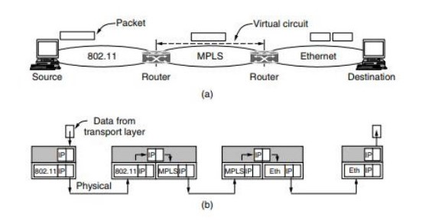

The network header contains the ultimate destination address, which is used to determine that the packet should be sent via the first router. So the packet is encapsulated in an 802.11 frame whose destination is the first router and transmitted. At the router, the packet is removed from the frame’s data field and the 802.11 frame header is discarded. The router now examines the IP address in the packet and looks up this address in its routing table. Based on this address, it decides to send the packet to the second router next.

For this part of the path, an MPLS virtual circuit must be established to the second router and the packet must be encapsulated with MPLS headers that travel this circuit. At the far end, the MPLS header is discarded and the network address is again consulted to find the next network layer hop. It is the destination itself. Since the packet is too long to be sent over Ethernet, it is split into two portions. Each of these portions is put into the data field of an Ethernet frame and sent to the Ethernet address of the destination. At the destination, the Ethernet header is stripped from each of the frames, and the contents are reassembled. The packet has finally reached its destination.

3.5.3 Tunneling

- Handling the general case of making two different networks interwork is exceedingly difficult. However, there is a common special case that is manageable.

- This case is where the source and destination hosts are on the same type of network, but there is a different network in between.

- As an example, think of an international bank with a TCP/IP-based Ethernet in Paris, a TCP/IP-based Ethernet in London, and a non-IP wide area network (e.g., ATM) in between, as shown in Fig.

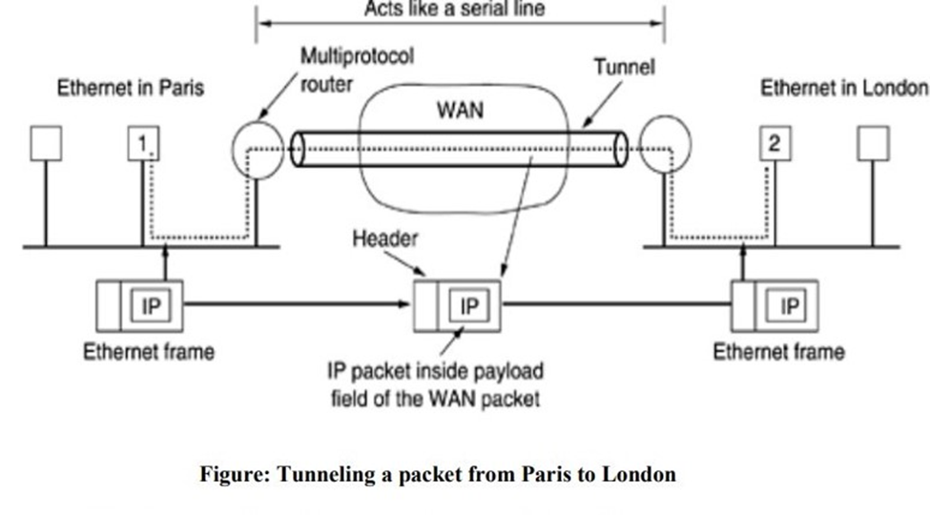

- The solution to this problem is a technique called tunneling.

- To send an IP packet to host 2, host 1 constructs the packet containing the IP address of host 2, inserts it into an Ethernet frame addressed to the Paris multiprotocol router, and puts it on the Ethernet. When the multiprotocol router gets the frame, it removes the IP packet, inserts it in the payload field of the WAN network layer packet, and addresses the latter to the WAN address of the London multiprotocol router. When it gets there, the London router removes the IP packet and sends it to host 2 inside an Ethernet frame.

- The WAN can be seen as a big tunnel extending from one multiprotocol router to the other. The IP packet just travels from one end of the tunnel to the other, snug in its nice box. Neither do the hosts on either Ethernet. Only the multiprotocol router has to understand IP and WAN packets. In effect, the entire distance from the middle of one multiprotocol router to the middle of the other acts like a serial line.

- Consider a person driving her car from Paris to London. Within France, the car moves under its own power, but when it hits the English Channel, it is loaded into a high-speed train and transported to England through the Chunnel (cars are not permitted to drive through the Chunnel). Effectively, the car is being carried as freight, as depicted in Fig. At the far end, the car is let loose on the English roads and once again continues to move

under its own power. Tunneling of packets through a foreign network works the same way.

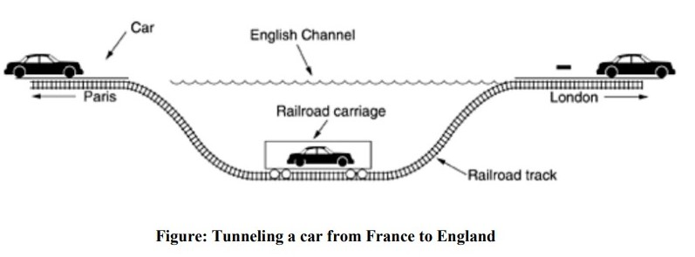

3.5.4 Internetwork Routing

- Routing through an internetwork is similar to routing within a single subnet, but with some added complications.

- Consider, for example, the internetwork of Fig. (a) in which five networks are connected by six (possibly multiprotocol) routers. Making a graph model of this situation is complicated by the fact that every router can directly access (i.e., send packets to) every other router connected to any network to which it is connected. For example, B in Fig. (a) can directly access A and C via network 2 and also D via network 3. This leads to the graph of Fig. (b).

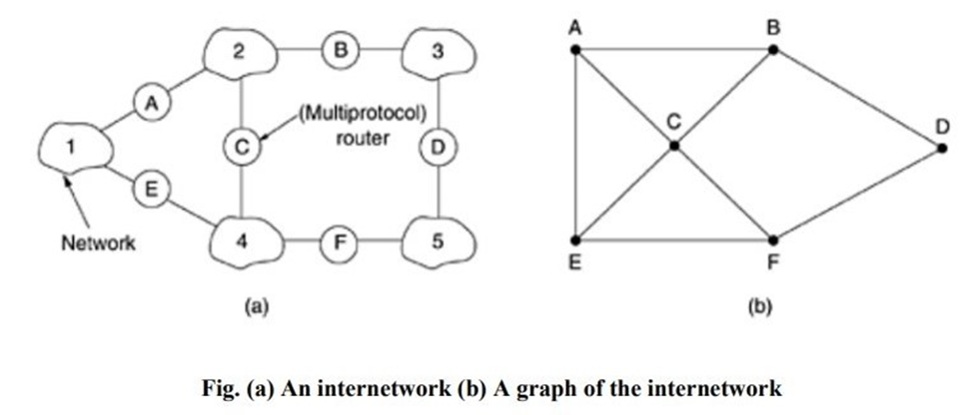

- Once the graph has been constructed, known routing algorithms, such as the distance vector and link state algorithms, can be applied to the set of multiprotocol routers.

- This gives a two-level routing algorithm: within each network an interior gateway protocol is used, but between the networks, an exterior gateway protocol is used (''gateway'' is an older term for ''router'').

- Network in an internetwork is independent of all the others, it is often referred to as an

Autonomous System (AS).

- A typical internet packet starts out on its LAN addressed to the local multiprotocol router (in the MAC layer header). After it gets there, the network layer code decides which multiprotocol router to forward the packet to, using its own routing tables. If that router can be reached using the packet's native network protocol, the packet is forwarded there directly. Otherwise it is tunneled there, encapsulated in the protocol required by the intervening network. This process is repeated until the packet reaches the destination network.
- One of the differences between internetwork routing and intranet work routing is that internetwork routing may require crossing international boundaries. Various laws suddenly come into play, such as Sweden's strict privacy laws about exporting personal data about Swedish citizens from Sweden. Another example is the Canadian law saying that data traffic originating in Canada and ending in Canada may not leave the country. This law means that traffic from Windsor, Ontario to Vancouver may not be routed via nearby Detroit, even if that route is the fastest and cheapest.

Another difference between interior and exterior routing is the cost. Within a single network, a single charging algorithm normally applies. However, different networks may be under different managements, and one route may be less expensive than another. Similarly, the quality of service offered by different networks may be different, and this may be a reason to choose one route over another.

3.5.5 Packet Fragmentation

- Each network imposes some maximum size on its packets. These limits have various causes, among them:

  - Hardware (e.g., the size of an Ethernet frame).

  - Operating system (e.g., all buffers are 512 bytes).

  - Protocols (e.g., the number of bits in the packet length field).

  - Compliance with some (inter)national standard.

  - Desire to reduce error-induced retransmissions to some level.

  - Desire to prevent one packet from occupying the channel too long.

- From the above factors maximum payloads range from 48 bytes (ATM cells) to 65,515 bytes (IP packets), although the payload size in higher layers is often larger.

- If the original source packet is too large to be handled by the destination network? The routing algorithm can hardly bypass the destination.
- The only solution to the problem is to allow gateways to break up packets into fragments, sending each fragment as a separate internet packet. Packet-switching networks, too, have trouble putting the fragments back together again.

Two opposing strategies exist for recombining the fragments back into the original packet.

The first strategy is to make fragmentation caused by a ''small-packet'' network transparent to any subsequent networks through which the packet must pass on its way to the ultimate destination. This option is shown in Fig. (a). In this approach, the small-packet network has gateways (most likely, specialized routers) that interface to other networks. When an oversized packet arrives at a gateway, the gateway breaks it up into fragments. Each fragment is addressed to the same exit gateway, where the pieces are recombined. In this way passage through the small-packet network has been made transparent. Subsequent networks are not even aware that fragmentation has occurred.

- Transparent fragmentation is straightforward but has some problems.

- For one thing, the exit gateway must know when it has received all the pieces, so either a count field or an ''end of packet'' bit must be provided.
- For another thing, all packets must exit via the same gateway. By not allowing some fragments to follow one route to the ultimate destination and other fragments a disjoint route, some performance may be lost.

- A last problem is the overhead required to repeatedly reassemble and then refragment a large packet passing through a series of small-packet networks. ATM requires transparent fragmentation.

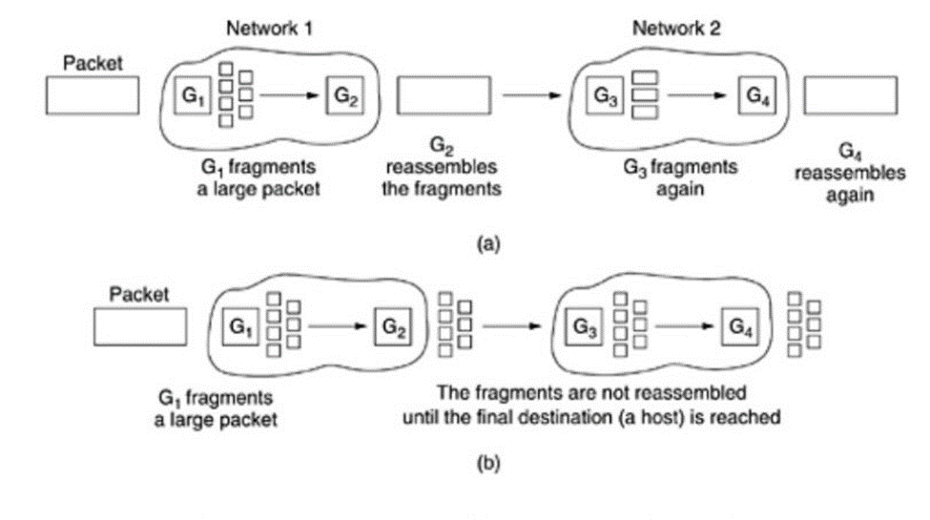

Fig: (a) Transparent Fragmentation (b) Nontransparent Fragmentation

The other fragmentation strategy is to refrain from recombining fragments at any intermediate gateways. Once a packet has been fragmented, each fragment is treated as through it were an original packet. All fragments are passed through the exit gateway (or gateways), as shown in Fig. (b). Recombination occurs only at the destination host. IP works this way.

- Nontransparent fragmentation also has some problems.

- For example, it requires every host to be able to do reassembly.

- Yet another problem is that when a large packet is fragmented, the total overhead increases because each fragment must have a header. Whereas in the first method this overhead disappears as soon as the small-packet network is exited, in this method the overhead remains for the rest of the journey.

- An advantage of nontransparent fragmentation, however, is that multiple exit gateways can now be used and higher performance can be achieved.

- When a packet is fragmented, the fragments must be numbered in such a way that the original data stream can be reconstructed.

- One way of numbering the fragments is to use a tree. If packet 0 must be split up, the pieces are called 0.0, 0.1, 0.2, etc. If these fragments themselves must be fragmented later on, the pieces are numbered 0.0.0, 0.0.1, 0.0.2, . . . , 0.1.0, 0.1.1, 0.1.2, etc.

- No duplicates are generated anywhere, this scheme is sufficient to ensure that all the pieces can be correctly reassembled at the destination, no matter what order they arrive in.

- However, if even one network loses or discards packets, end-to-end retransmissions are needed, with unfortunate effects for the numbering system.

- Suppose that a 1024-bit packet is initially fragmented into four equal-sized fragments, 0.0, 0.1, 0.2, and 0.3. Fragment 0.1 is lost, but the other parts arrive at the destination. Eventually, the source time out and retransmits the original packet again.

- When a packet is fragmented, all the pieces are equal to the elementary fragment size except the last one, which may be shorter. An internet packet may contain several fragments, for efficiency reasons.

- The internet header must provide the original packet number and the number of the (first) elementary fragment contained in the packet.

- A bit indicating that the last elementary fragment contained within the internet packet is the last one of the original packet.

This approach requires two sequence fields in the internet header:

- The original packet number and the fragment number. There is clearly a trade-off between the size of the elementary fragment and the number of bits in the fragment number. Because the elementary fragment size is presumed to be acceptable to every network, subsequent fragmentation of an internet packet containing several fragments causes no problem. The ultimate limit here is to have the elementary fragment be a single bit or byte, with the fragment number then being the bit or byte offset within the original packet, as shown in Fig.

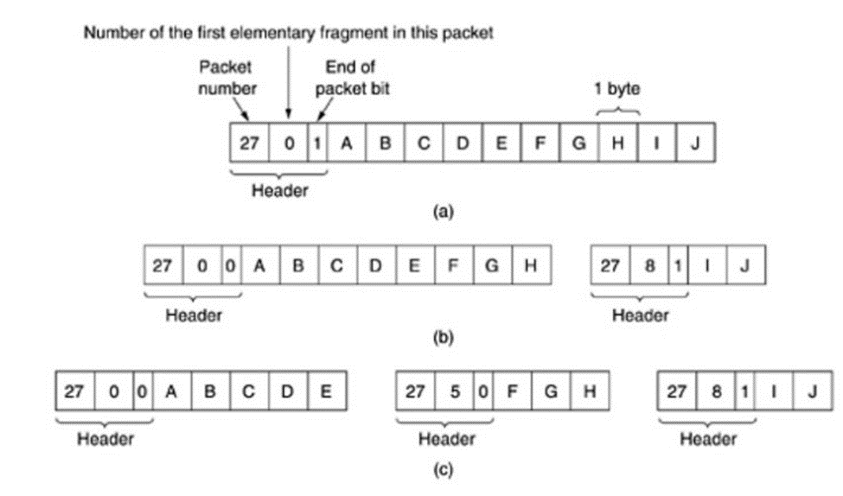

Figure: Fragmentation when the elementary data size is 1 byte.

- Fig (a) Original packet containing 10 data bytes

- Fig (b) Fragments after passing through a network with maximum packet size of 8 payload bytes plus header.

- Fig (c) Fragments after passing through a size 5 gateway.

Some internet protocols take this method even further and consider the entire transmission on a virtual circuit to be one giant packet, so that each fragment contains the absolute byte number of the first byte within the fragment.

